REDLINE
Medical Supplies & Equipment Trading
ريد لاين للتجارة في المستلزمات والمعدات الطبية

Solution Design Document (SSD)
وثيقة تصميم الحل
Architecture, structure, security, workflows, reporting and migration

Project | Odoo ERP Implementation - Graduation Project (simulation)
Document code | RL-SSD-001
Version | 1.0 (final)
Preparation date | 25 October 2026
Business reporting period | 1 May 2026 – 30 September 2026
Target platform | Odoo 19.0 (Enterprise edition assumed)
Prepared by | Mohamed Mahmoud Abdel Bary, Mohamed Essam El-Din Youssef, Ahmed Mahmoud Mohamed, Fathy Adel Fathy, Omnia Haitham
Currency | EGP - Egyptian Pound
Disclaimer: all companies, partners, bank details and transactions in this project are fictional or illustrative simulation data. Nothing in this document claims that the configuration has been installed, imported or tested on a live Odoo server.

Contents
1 | Introduction and design principles
2 | Solution architecture and modules
3 | Module relationships and dependencies
4 | Organizational structure and master-data design
5 | Branches and warehouses in a single-company model
6 | Warehouse routes and inventory design
7 | Security model
8 | Process designs (six workflow diagrams)
9 | Accounting integration
10 | Reporting design
11 | Migration strategy
12 | Open design decisions and limitations
Appendix | Charter, user-guide outline
Section numbers are used for cross-references throughout the document set (e.g. 'SSD 4.2' = Solution Design Document, section 4.2).

1. Introduction and design principles
This document describes how Odoo (Odoo 19.0 (Enterprise edition assumed)) will be configured to meet the 75 requirements in the BRD for RedLine Medical Supplies & Equipment Trading. It covers architecture, structure, security, workflows, accounting integration, reporting and migration.

1.1 Project charter (summary)
Item | Statement
Objective | Implement an integrated ERP for trading medical equipment, consumables and spare parts with full lot/serial/expiry traceability and reconciled accounting
Scope | Contacts, Sales, CRM, Purchase, Inventory, Accounting, basic reporting/dashboards, data migration templates, UAT, training material
Out of scope | Manufacturing, HR/payroll, e-commerce, point-of-sale hardware, live server installation (documented only), statutory tax filing
Team | Mohamed Mahmoud Abdel Bary (Team Leader - Apps, Settings, Permissions & Design); Mohamed Essam El-Din Youssef (Sales & CRM); Ahmed Mahmoud Mohamed (Inventory & Data Upload); Fathy Adel Fathy (Purchase, Quality & Testing); Omnia Haitham (Accounting & Finance)
Governance | Team leader approves design and deliverables; changes recorded in the RTM; weekly review
Success criteria | All deliverables complete and consistent; every requirement traced to a test; validation report clean

1.2 Design principles
- Standard first: use standard features and configuration before customization.
- One legal company, many analytic dimensions: branches are reporting/security units, not separate books.
- Traceability by default: every stock move carries lot or serial.
- Quarantine is a place, not a flag: failed, returned, damaged and near-expiry stock physically moves to the QRT warehouse.
- Reconcile always: valuation to ledger, subledgers to control accounts.
- Be honest about limits: customizations and Enterprise features are labelled as proposed/unverified.

2. Solution architecture and modules
Section owner: Mohamed Mahmoud Abdel Bary
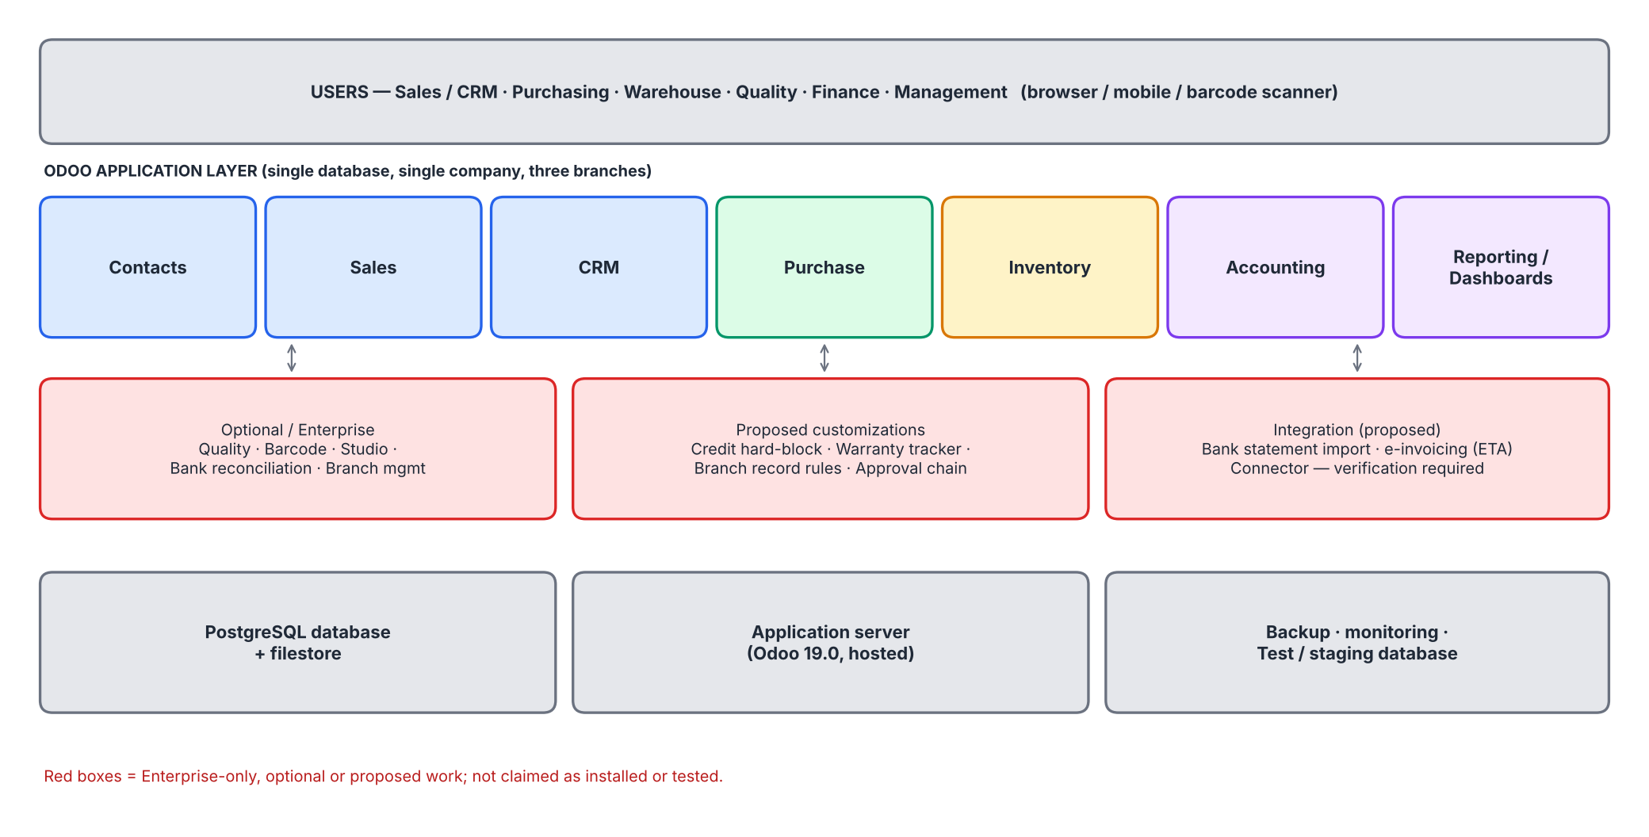
Figure 1 - Logical architecture
Module | Technical name | Edition | Use in RedLine | Class
Contacts | contacts / base | Community+ | Customers, vendors, bilingual names, terms, credit limit | Standard
Sales | sale_management | Community+ | Quotations, pricelists, orders, delivery link | Standard
CRM | crm | Community+ | Leads, opportunity pipeline, sales teams per branch, activities, forecast | Standard (config)
Purchase | purchase | Community+ | RFQ, PO approval, three-way match, replenishment | Standard
Inventory | stock | Community+ | Warehouses, routes, lots/serials, expiry, FEFO, quarantine, adjustments | Standard (config)
Product Expiry | product_expiry | Community+ | Expiration dates, alerts, FEFO | Standard (config)
Accounting | account | Enterprise (full UI) | Invoices, bills, payments, valuation, VAT, reports | Standard / Enterprise
Stock Accounting | stock_account | Community+ | Automated valuation, Anglo-Saxon | Standard
Quality | quality_control | Enterprise | Receipt inspection and failure routing | Enterprise
Barcode | stock_barcode | Enterprise | Scanning on receipts, picks, counts | Optional
Studio | web_studio | Enterprise | Custom fields/approvals (warranty, credit, approval chain) | Optional / customization
Dashboards/Spreadsheet | spreadsheet_dashboard | Enterprise | KPI dashboard | Optional

Edition and technical names are indicative and must be verified on the installed build.

2.1 CRM pipeline design
Section owner: Mohamed Essam El-Din Youssef
The CRM app manages the path from lead to won order. Stages: New (10%), Qualified (25%), Quotation Sent (50%), Negotiation (75%), Won (100%), Lost (0%, lost reason mandatory). One sales team per branch (Nasr City, Maadi, Mohandeseen); quotations are created from the opportunity so that sales order, delivery and invoice stay linked. Retail counter sales do not use the pipeline. Tender tracking (reference, deadline, bid bond) uses tags and activities as standard and custom fields as a proposed customization.
Element | Design | Requirement
Lead sources | Hospital tender, referral, exhibition, website, email, existing customer | CRM-001
Stages and probability | New 10, Qualified 25, Quotation Sent 50, Negotiation 75, Won 100, Lost 0 | CRM-002
Quotation link | Create quotation from opportunity; confirmed order marks Won | CRM-003
Sales teams | Nasr City, Maadi, Mohandeseen teams with placeholder salespeople | CRM-004
Activities | Calls, visits, demos with reminders | CRM-005
Reports | Forecast, weighted revenue, win rate, lost reasons by branch | CRM-006, CRM-007
Tender tracking | Tags and activities; custom fields proposed | CRM-008

3. Module relationships and dependencies
From | To | Relationship
Sales | Inventory | Confirmed order creates delivery orders per source warehouse; reservation by lot/serial
Purchase | Inventory | Confirmed PO creates receipt; reordering rules create RFQs
Inventory | Accounting | Stock valuation entries (Dr/Cr inventory, GRNI, stock interim delivered) at each move
Sales | Accounting | Invoice from delivered quantity; revenue, VAT, COGS recognition
Purchase | Accounting | Vendor bill matched to receipts; input VAT
Contacts | All | Partner terms, credit limit, tax, branch; analytic default
Quality | Inventory | Failed check blocks putaway and triggers quarantine transfer
Accounting | Reporting | Ledgers, aged reports, KPI dashboards by branch (analytic)

4. Organizational structure and master-data design
The organizational chart (11 units) and role matrix are in Organization_and_Accounting_Charts.xlsx. Master data design:
Master data | Key design | Volume (simulation) | Source
Company / branches | 1 company, 3 branches (BR-NSC, BR-MAA, BR-MOH) | 1 + 3 | 01_company_branches.csv
Warehouses / locations | 4 warehouses; Input/Output for EQP and CON; QRT/Quarantine | 4 / 8 | 02, 03
Product categories | 3 roots, 10 categories; valuation/income/COGS accounts per category | 10 | 04, 10
Products | Internal ref, Arabic/English names, EAN-13 barcode, tracking, expiry, reorder rules | 24 | 05, 13
Partners | 13 customers, 6 vendors; terms, credit limit, tax ID placeholder, branch | 13 / 6 | 06, 07
Lots and serials | Lot per receipt/expiry; serial per unit | 42 lots, 186 serials | 11
Chart of accounts | 101 accounts, 6 digits, hierarchical groups | 101 | 08

Naming and numbering conventions: customers CUS-###, vendors VEN-###; product references EQ-/CN-/SP-; serials SN-<ABBR>-<YYMM>-####; lots LOT-<ABBR>-<YYMM><n>; documents PO/2026/####, SO/2026/####, <WH>/IN/#####, <WH>/OUT/#####, INV/2026/#####, BILL/2026/#####.

5. Branches and warehouses in a single-company model
Section owner: Mohamed Mahmoud Abdel Bary
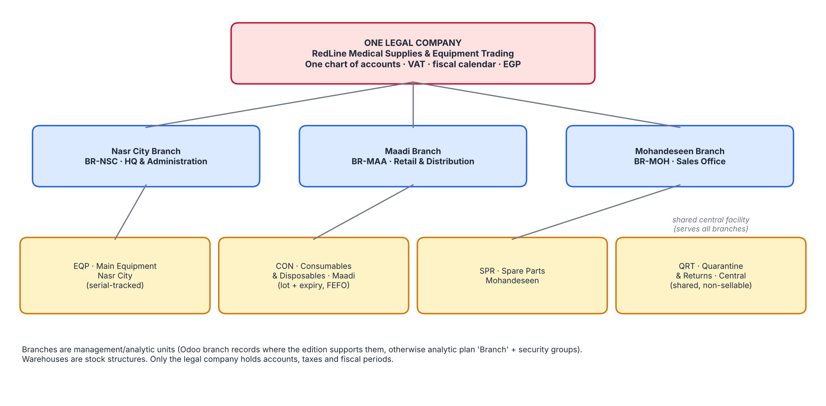
Figure 2 - Single legal company, three branches, four warehouses

5.1 Mapping
Branch | Primary warehouse | Responsibilities
Nasr City (BR-NSC) - HQ | EQP (also administers QRT) | Administration, capital-equipment sales and stock
Maadi (BR-MAA) - Retail & Distribution | CON | Consumables distribution, retail counter, cash safe CSH2
Mohandeseen (BR-MOH) - Sales Office | SPR | Key-account sales office, spare parts, service

5.2 How operations work
- Every sales order and invoice carries the responsible branch (analytic plan); the delivery is made from the product's home warehouse (EQP, CON, SPR), so a Mohandeseen sale of consumables is shipped from CON.
- Stock moves between warehouses are internal transfers: they change location, not company-wide quantity or valuation.
- Retail cash receipts go to the branch cash safe journal (CSH1-3); bank receipts to CIB1/NBE1.
- The Quarantine & Returns warehouse (QRT) receives from all branches.

5.3 Limitations of standard branch handling
Topic | Standard behaviour / limit | Proposed handling | Status
Branch records | Branch (child company) management exists in recent Odoo versions and is described as part of multi-company functionality; availability and plan/edition must be confirmed. Parent chart of accounts, currency and taxes are shared; journals can be branch-specific. | If available: three branches under the parent. Otherwise analytic plan 'Branch' on lines. | Verify
Branch P&L | Analytic reporting filters by plan; balance sheet by branch is not natively separated when branches are analytic only | Management P&L by branch via analytic; balance sheet at company level | Limitation documented
Access control | Record rules by company/branch exist; by warehouse or analytic branch require custom rules/groups | Groups per warehouse; custom record rules (SEC-002) | Customization (proposed)
Inter-branch stock | Warehouses belong to one company; transfers are internal | No inter-company invoices needed | Standard
Branch numbering | Sequences are per journal/company, not per branch | Use branch-specific journals if required or accept shared sequence | Decision pending
VAT registration | Branches may share or have their own VAT number | Share the parent's registration (assumption) | Confirm with tax advisor

Decision. Three independent legal companies are deliberately NOT created: they would split the chart of accounts, require inter-company flows and complicate consolidation without a legal reason.

6. Warehouse routes and inventory design
Section owner: Ahmed Mahmoud Mohamed
Route | Flow | Warehouses
Buy (2-step) | Vendor -> Input -> (quality check) -> Stock | EQP, CON
Buy (1-step) | Vendor -> Stock | SPR
Deliver (2-step) | Stock -> Output (pick) -> Customer (ship) | EQP, CON
Deliver (1-step) | Stock -> Customer | SPR
Quarantine in | Any warehouse Stock -> QRT/Quarantine (internal transfer) | All -> QRT
Restock | QRT/Quarantine -> home Stock (internal transfer) | QRT -> EQP/CON/SPR
Return to vendor | QRT/Quarantine -> Vendor | QRT
Customer return | Customer -> QRT/Quarantine | QRT
Scrap | QRT (or Stock) -> Virtual/Scrap (reason) | QRT

- Reordering rules: min/max per product at its home warehouse; vendor lead times; scheduler daily (weekly in the simulation).
- FEFO: removal strategy on category 'Medical Consumables'; picking excludes lots under 60 days to expiry through quarantine isolation.
- Putaway: Input -> Stock by category; serial products to EQP/Stock.
- Inventory controls: negative stock off; counts quarterly (ABC) with monthly cycle counts for consumables; adjustments through account 540100.

7. Security model
Section owner: Mohamed Mahmoud Abdel Bary
Layer | Design | Class
Authentication | Named users, strong passwords, MFA for administrators; no shared accounts | Standard
Groups | Sales, Purchase, Inventory, Quality (custom), Accounting, Administration; see BDC 6 | Standard (config)
Record rules | Own-branch/own-warehouse visibility | Customization (proposed)
Approvals | PO > EGP 250k (double validation); quotation > EGP 500k; payment approval by Finance Manager | Standard + Studio/custom
Segregation of duties | Different users create vendor, approve bill, release payment | Custom rule (proposed)
Audit trail | Tracked fields (prices, credit limits, terms); chatter; access logs | Standard
Data protection | Backups encrypted; test data masked; no credentials in documents | Manual procedure

8. Process designs (six workflow diagrams)
Section owner: Mohamed Mahmoud Abdel Bary

8.1 Procure-to-Pay
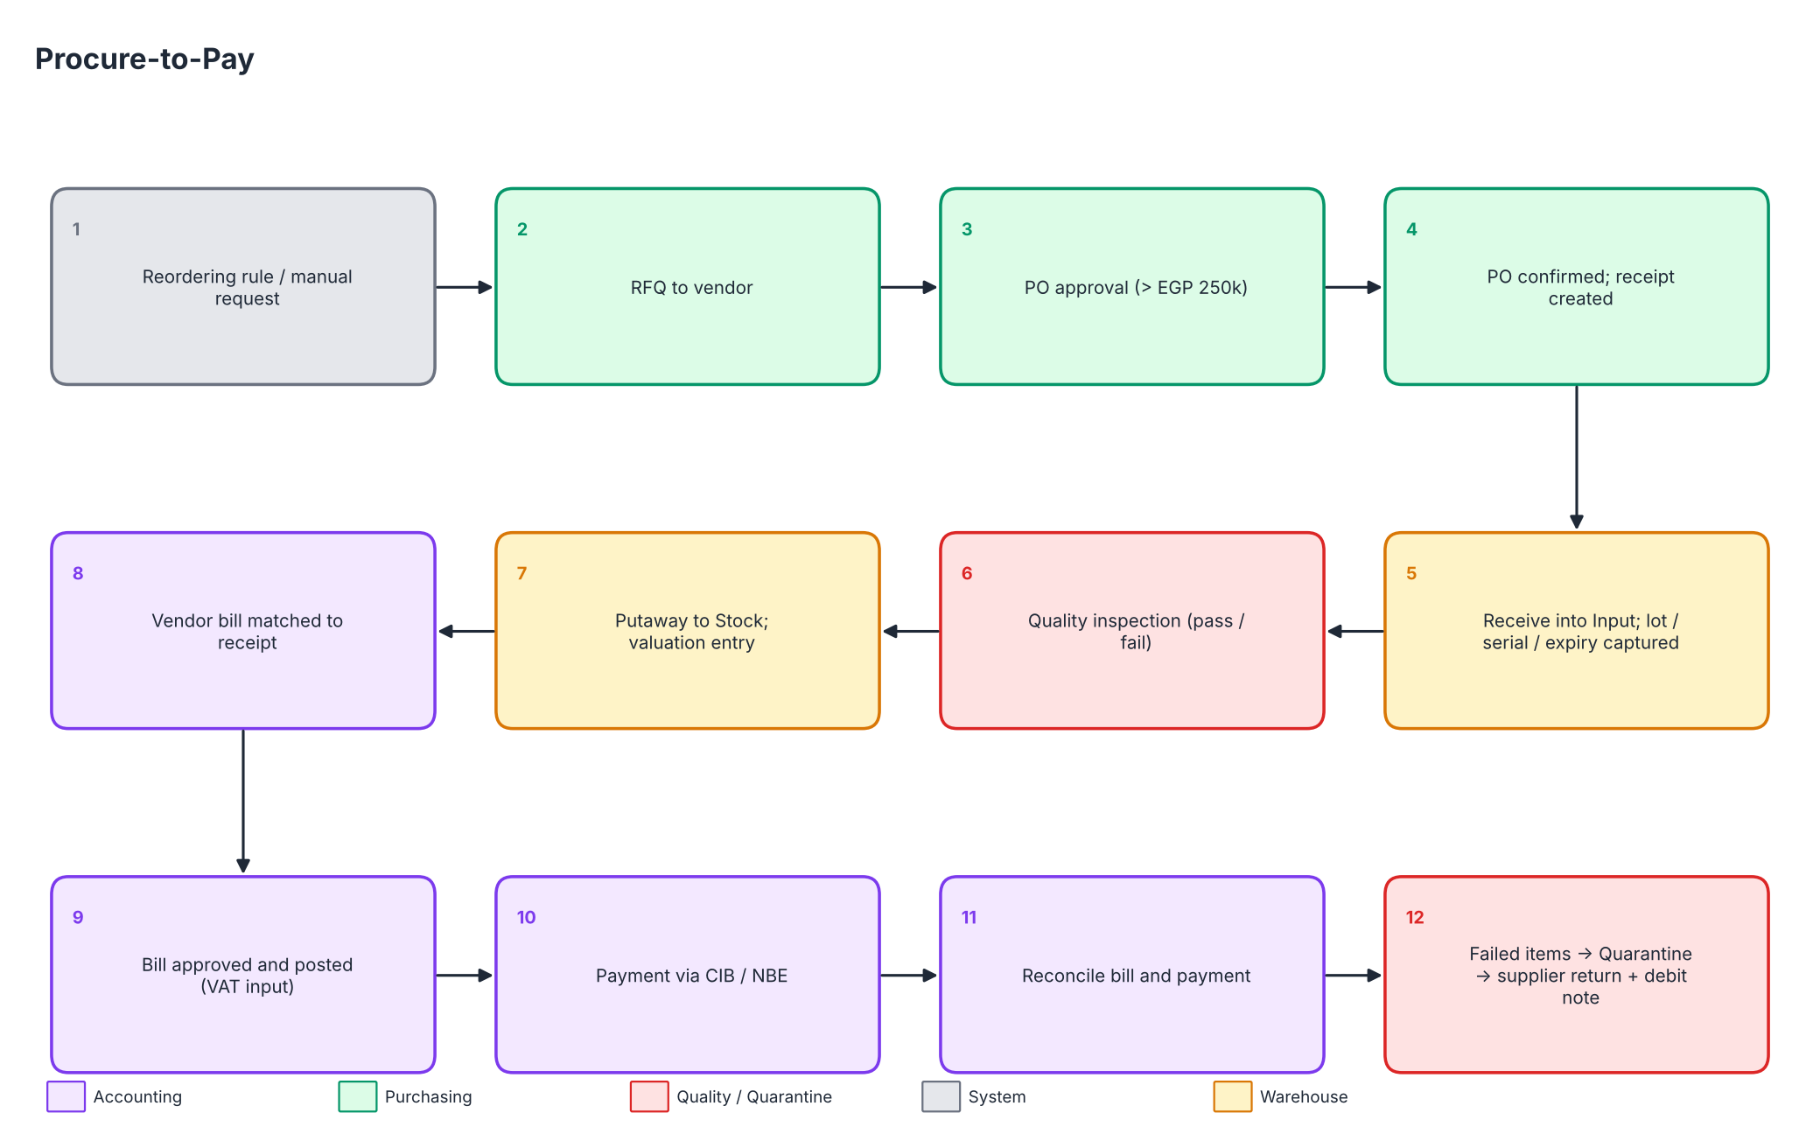
Figure 3 - Procure-to-Pay
Replenishment starts from reordering rules or a manual request. Orders above EGP 250,000 need approval. Bills are matched to received quantities; failed receipts return to the vendor through quarantine with a debit note. Related: PUR-001..007, ACC-002, ACC-003.

8.2 Order-to-Cash
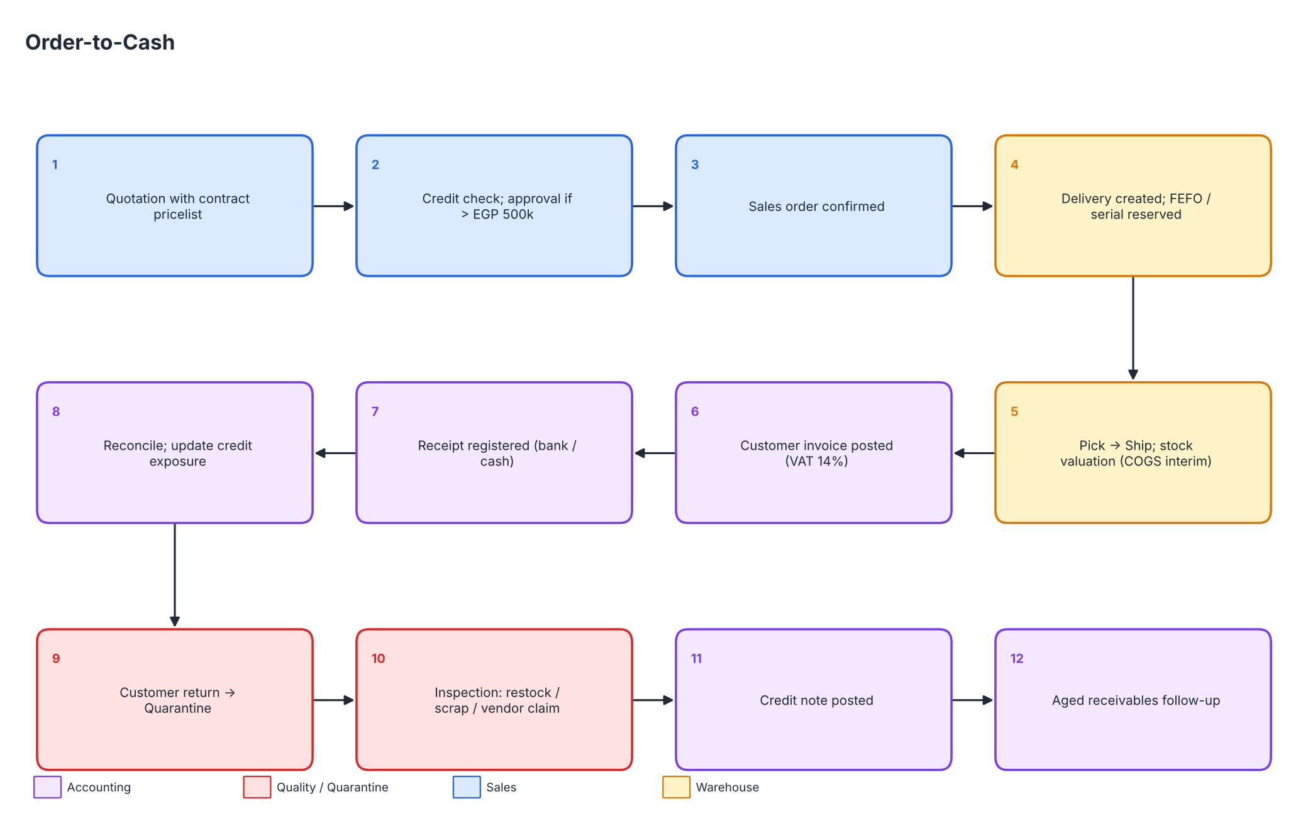
Figure 4 - Order-to-Cash
Credit exposure is checked at confirmation; delivery reserves FEFO lots or serials; the invoice posts revenue, VAT and COGS; returns are credited and inspected. Related: SAL-001..009, ACC-001, ACC-004.

8.3 Inventory Receipt and Putaway
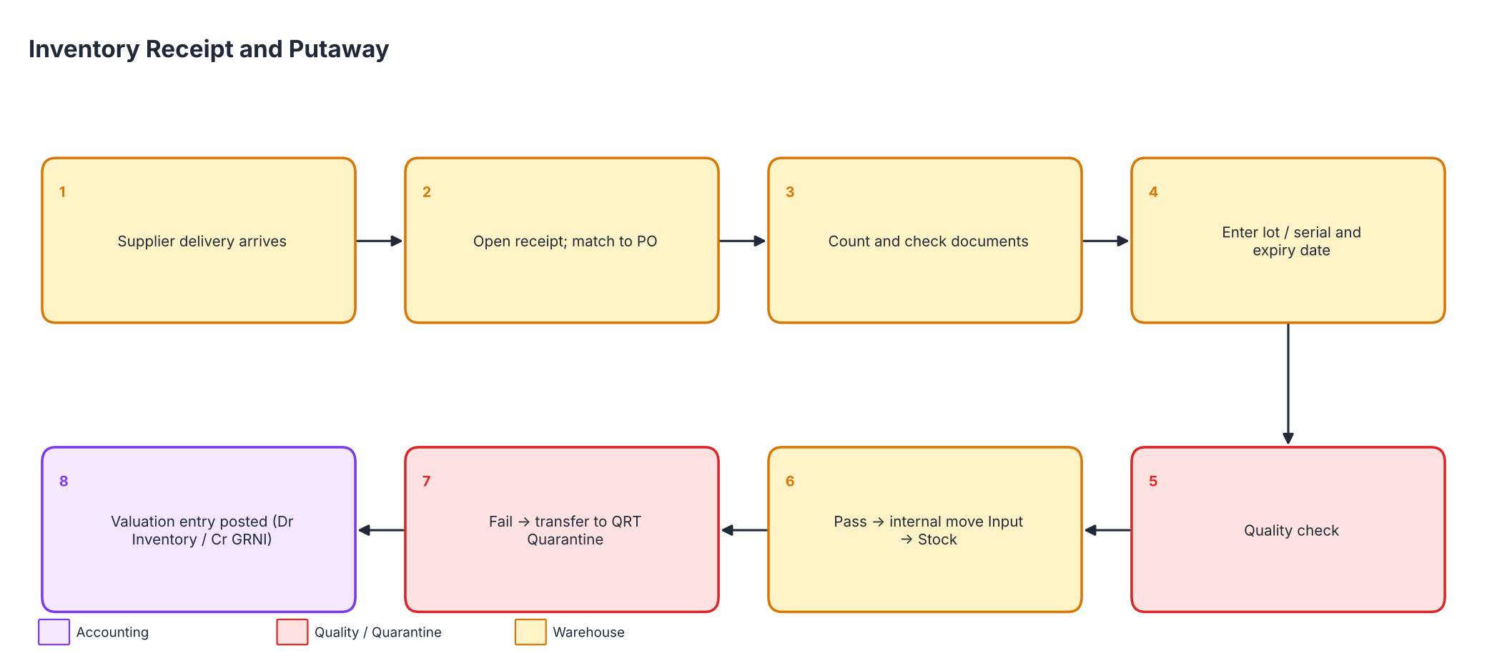
Figure 5 - Inventory Receipt and Putaway
Receipts enter an Input location; lot/serial and expiry are mandatory; quality check decides putaway or quarantine. Related: INV-001..005, PUR-007.

8.4 Internal Stock Transfers
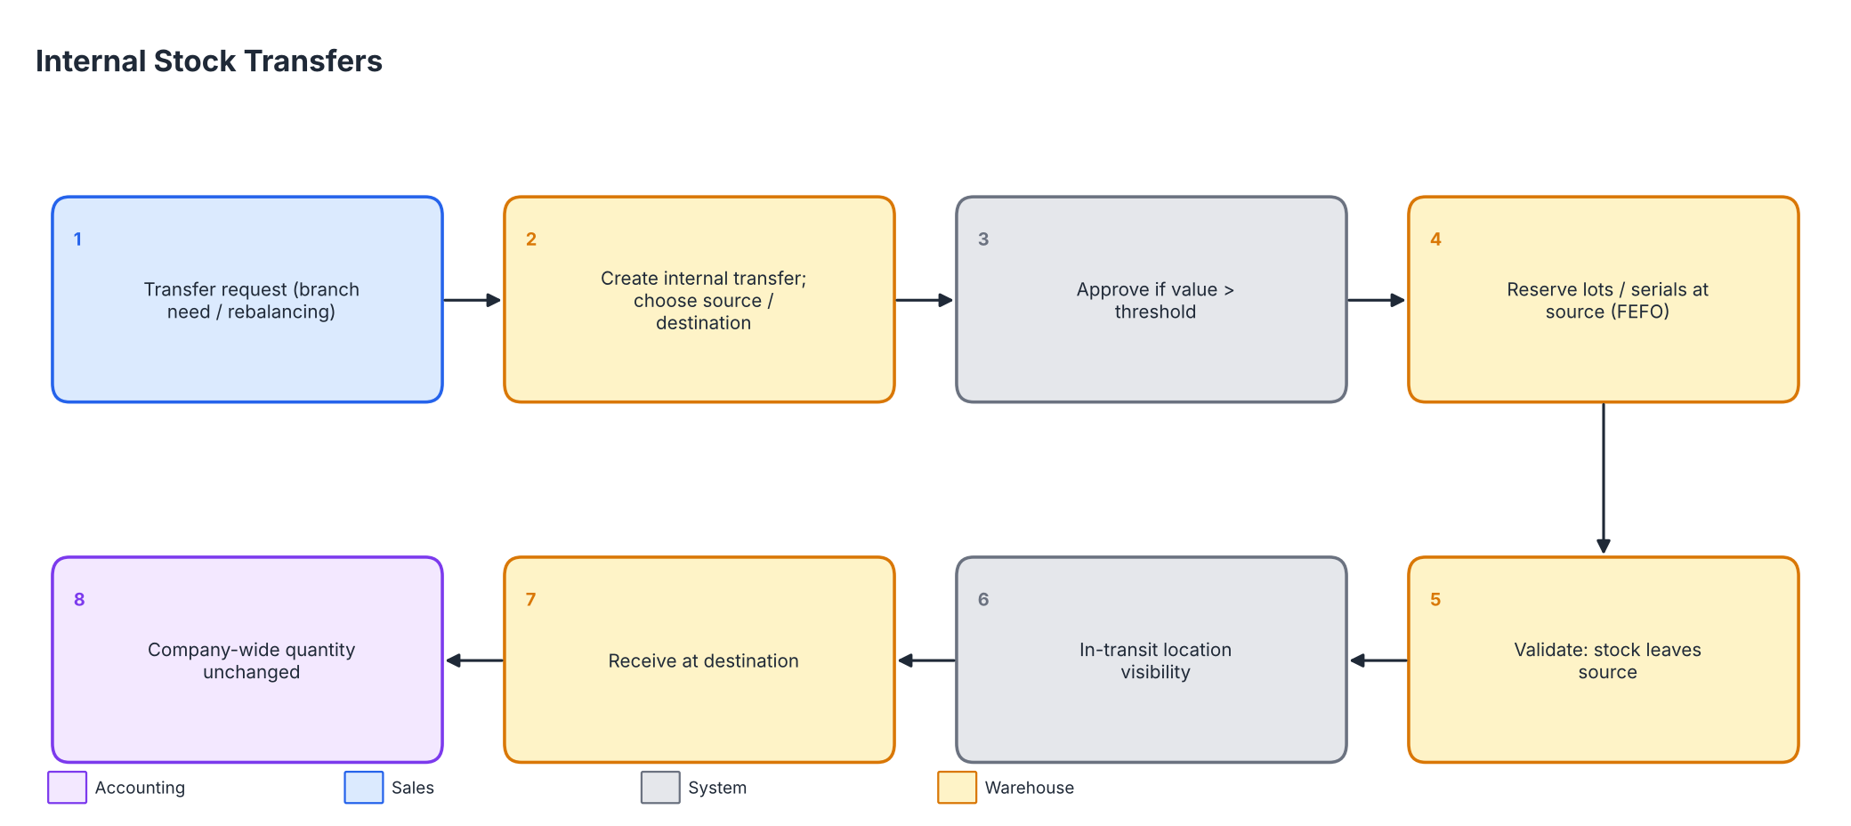
Figure 6 - Internal Stock Transfers
Internal transfers reserve at source, move through a transit view and are received at destination; company-wide quantity and value do not change. Related: INV-008.

8.5 Returns and Quarantine
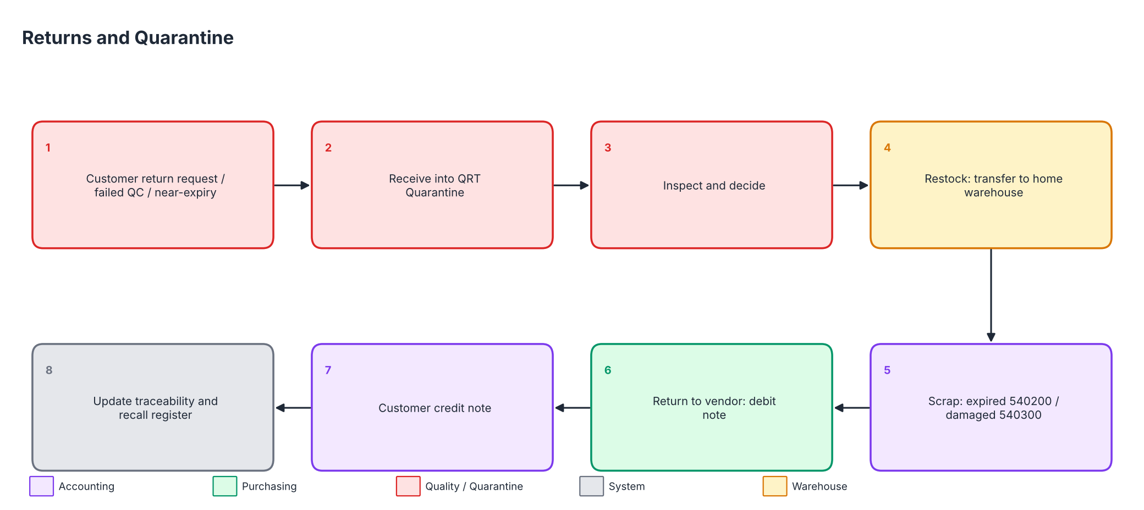
Figure 7 - Returns and Quarantine
All returns, failed-inspection goods and near-expiry lots go to QRT; the Quality Officer decides restock, scrap (540200/540300) or vendor return. Related: SAL-008, PUR-005, INV-009, INV-010.

8.6 Period-End Inventory and Accounting Reconciliation
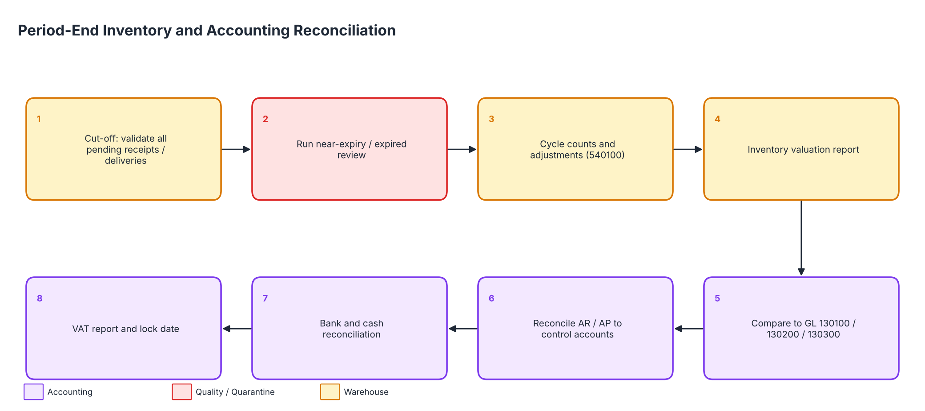
Figure 8 - Period-End Inventory and Accounting Reconciliation
At month-end cut-off, near-expiry review, cycle counts, valuation report to GL, AR/AP to control accounts, bank/cash reconciliation, VAT report and lock date. Related: INV-011, INV-017, ACC-008, ACC-009, ACC-012.

9. Accounting integration
Section owner: Omnia Haitham
Event | Journal entry (EGP) | Accounts
Goods receipt | Dr Inventory / Cr GRNI at vendor cost | 130100/200/300 ; 210500
Vendor bill | Dr GRNI + Dr VAT input / Cr Trade payables | 210500 ; 140300 ; 210100
Delivery | Dr Stock interim delivered / Cr Inventory at FIFO cost | 130600 ; 1301xx
Customer invoice | Dr Receivables / Cr Revenue + Cr VAT output; Dr COGS / Cr Stock interim delivered | 120100 ; 4101xx ; 220100 ; 5101xx ; 130600
Credit note | Dr Sales returns + Dr VAT output / Cr Receivables; Dr Stock interim / Cr COGS (returned goods) | 420100 ; 220100 ; 120100
Scrap expired / damaged | Dr 540200 / 540300, Cr Inventory | 540200 ; 540300
Count adjustment | Dr/Cr 540100 against Inventory | 540100
Payment | Dr Bank/Cash / Cr Receivables; Dr Payables / Cr Bank | 110101-3, 110201-2

Simulated check: 737 journal entries produced a balanced trial balance (debits = credits = EGP 222,538,042.78). Receivables (EGP 29,532,073.42), payables (EGP 2,662,739.04), output VAT (EGP 4,232,652.52) and input VAT (EGP 3,436,752.76) agree with the sub-ledger workbooks. This is a mathematical validation of the simulated model, not an Odoo functional test.

10. Reporting design
Section owner: Mohamed Essam El-Din Youssef
Report / dashboard | Source | Grouping | Class
Sales analysis | Sales/Invoices | Branch, customer class, category, month | Standard
P&L by branch | Accounting + analytic | Branch plan | Standard
Inventory valuation | Inventory | Warehouse, category, lot | Standard
Near-expiry / expired | Lots | Days to expiry buckets | Standard (config)
Aged AR/AP | Accounting | Buckets | Standard
Traceability | Stock moves | Lot/serial | Standard
Management KPI dashboard | Spreadsheet dashboards | Sales, margin, AR, stock value, near-expiry value | Enterprise / optional

11. Migration strategy
Section owner: Ahmed Mahmoud Mohamed
- Prepare: freeze legacy master data; cleanse duplicates; approve chart of accounts.
- Load configuration and master data in dependency order (Import_Package/README.md).
- Load lots/serials, then opening stock (EGP 24,170,200.00 at 1 May 2026) by inventory adjustment; reclassify counter-account to 310200.
- Load opening receivables/payables as open invoices (nil in this simulation).
- Treat five-month history as reference (summary journal or scripted import); reconcile totals to the trial balance.
- Run validation: counts, keys, duplicates, dates, quantity and value reconciliations; freeze legacy; go-live.

12. Open design decisions and limitations
- Confirm Odoo version/edition (Odoo 19.0 assumed; 'Odoo 20' unverified) and branch-management availability.
- Hard credit-limit block, warranty tracker, approval chain and branch record rules are proposed customizations (TPD 6).
- Accountant to confirm VAT treatment, withholding tax, e-invoicing and chart of accounts.
- No live Odoo execution has taken place; all quantitative claims refer to the simulation.

Appendix. User-guide outline
Guide | Contents
Sales user | Create customer, quote, confirm, deliver, invoice, handle return
Purchasing user | RFQ, PO approval, receipt follow-up, bill matching, supplier return
Warehouse user | Receipt with lot/serial/expiry, putaway, FEFO delivery, transfer, count
Quality officer | Inspection, quarantine disposition, scrap, near-expiry review, recall trace
Accountant | Bill/invoice posting, payments, reconciliation, valuation to GL, lock date
Manager | Approvals, dashboards, branch reports

